TSL Tutor Project Scheme

© Anar Kazimov and Software Gates Team, 2016

Firstly, we need to define the 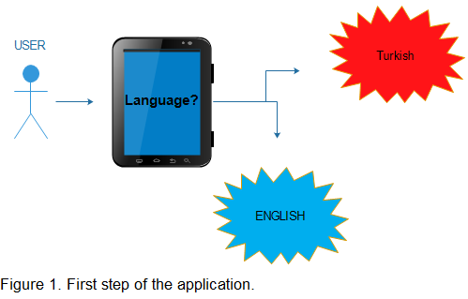most comfortable language for our user. This is the cornerstone of the whole project because all our hierarchy will be based on this. The dual language system will significantly increase our user base.

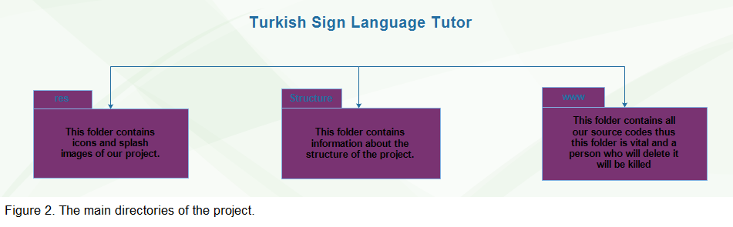

Figure 2 illustrates three main folders of our projecy. We will mainly concentrate on the www folder but designers will need to explore the ‘res’ folder.